**EXPERIMENT NO. 02**

|  |
| --- |
| NAME: Ayush Vinod Upadhyay  ROLL NO: I025  SAP ID: 60003220131  BRANCH: Information Technology  BATCH: 1 |

#include <stdio.h>

void calculateWaitingTime(int processes[], int n, int burst_time[], int waiting_time[])

{

    waiting_time[0] = 0; // Waiting time for the first process is 0

    for (int i = 1; i < n; i++)

    {

        waiting_time[i] = burst_time[i - 1] + waiting_time[i - 1];

    }

}

void calculateTurnaroundTime(int processes[], int n, int burst_time[], int waiting_time[], int turnaround_time[])

{

    for (int i = 0; i < n; i++)

    {

        turnaround_time[i] = burst_time[i] + waiting_time[i];

    }

}

void displayGanttChart(int processes[], int n, int burst_time[])

{

    printf("\nGantt Chart:\n");

    for (int i = 0; i < n; i++)

    {

        printf("| P%d ", processes[i]);

    }

    printf("|\n");

    int current_time = 0;

    for (int i = 0; i < n; i++)

    {

        printf("%d\t", current_time);

        current_time += burst_time[i];

    }

    printf("%d\n", current_time);

}

void calculateAverageWaitingTime(int processes[], int n, int burst_time[], int waiting_time[])

{

    float total_waiting_time = 0;

    for (int i = 0; i < n; i++)

    {

        total_waiting_time += waiting_time[i];

    }

    float avg_waiting_time = total_waiting_time / n;

    printf("Average Waiting Time: %.2f\n", avg_waiting_time);

}

int main()

{

    int n;

    printf("Enter the number of processes: ");

    scanf("%d", &n);

    int processes[n], burst_time[n], waiting_time[n], turnaround_time[n];

    for (int i = 0; i < n; i++)

    {

        printf("Enter burst time for process P%d: ", i + 1);

        scanf("%d", &burst_time[i]);

        processes[i] = i + 1;

    }

    calculateWaitingTime(processes, n, burst_time, waiting_time);

    calculateTurnaroundTime(processes, n, burst_time, waiting_time, turnaround_time);

    printf("\nProcess\tBurst Time\tWaiting Time\tTurnaround Time\n");

    for (int i = 0; i < n; i++)

    {

        printf("%d\t%d\t\t%d\t\t%d\n", processes[i], burst_time[i], waiting_time[i], turnaround_time[i]);

    }

    displayGanttChart(processes, n, burst_time);

    calculateAverageWaitingTime(processes, n, burst_time, waiting_time);

    return 0;

}

**Q2**

#include <stdio.h>

struct Process

{

    int id;

    int arrival_time;

    int burst_time;

    int priority;

    int waiting_time;

    int turnaround_time;

};

void sjf_with_priority(struct Process processes[], int n)

{

    int total_waiting_time = 0;

    int total_turnaround_time = 0;

    for (int i = 0; i < n; i++)

    {

        for (int j = i + 1; j < n; j++)

        {

            if (processes[i].arrival_time > processes[j].arrival_time || (processes[i].arrival_time == processes[j].arrival_time &&

                                                                          (processes[i].priority > processes[j].priority ||

                                                                           (processes[i].priority == processes[j].priority && processes[i].burst_time > processes[j].burst_time))))

            {

                struct Process temp = processes[i];

                processes[i] = processes[j];

                processes[j] = temp;

            }

        }

    }

    int current_time = 0;

    for (int i = 0; i < n; i++)

    {

        if (processes[i].arrival_time > current_time)

        {

            current_time = processes[i].arrival_time;

        }

        processes[i].waiting_time = current_time - processes[i].arrival_time;

        processes[i].turnaround_time = processes[i].waiting_time + processes[i].burst_time;

        total_waiting_time += processes[i].waiting_time;

        total_turnaround_time += processes[i].turnaround_time;

        current_time += processes[i].burst_time;

    }

    printf("\nGantt Chart:\n");

    printf("0");

    for (int i = 0; i < n; i++)

    {

        printf("->P%d->%d", processes[i].id, current_time);

    }

    printf("\n\nTABLE\n");

    printf("Process AT BT WT TAT\n");

    for (int i = 0; i < n; i++)

    {

        printf("P%d\t%d\t%d\t%d\t%d\n", processes[i].id, processes[i].arrival_time, processes[i].burst_time, processes[i].waiting_time, processes[i].turnaround_time);

    }

    double avg_waiting_time = (double)total_waiting_time / n;

    double avg_turnaround_time = (double)total_turnaround_time / n;

    printf("\nAverage Turnaround Time: %.6lf\n", avg_turnaround_time);

    printf("Average Waiting Time: %.6lf\n", avg_waiting_time);

}

int main()

{

    int n;

    printf("Enter the number of processes: ");

    scanf("%d", &n);

    struct Process processes[n];

    for (int i = 0; i < n; i++)

    {

        processes[i].id = i + 1;

        printf("Enter the arrival time for process P%d: ", i + 1);

        scanf("%d", &processes[i].arrival_time);

        printf("Enter the burst time for process P%d: ", i + 1);

        scanf("%d", &processes[i].burst_time);

        printf("Enter the priority for process P%d: ", i + 1);

        scanf("%d", &processes[i].priority);

    }

    sjf_with_priority(processes, n);

    return 0;

}

**Q3**

#include <stdio.h>

void priorityScheduling(int processes[], int n, int burst_time[], int priority[], int arrival_time[])

{

    int waiting_time[n], turnaround_time[n];

    for (int i = 0; i < n - 1; i++)

    {

        for (int j = 0; j < n - i - 1; j++)

        {

            if (arrival_time[j] > arrival_time[j + 1])

            {

                int temp = arrival_time[j];

                arrival_time[j] = arrival_time[j + 1];

                arrival_time[j + 1] = temp;

                temp = priority[j];

                priority[j] = priority[j + 1];

                priority[j + 1] = temp;

                temp = burst_time[j];

                burst_time[j] = burst_time[j + 1];

                burst_time[j + 1] = temp;

                temp = processes[j];

                processes[j] = processes[j + 1];

                processes[j + 1] = temp;

            }

        }

    }

    waiting_time[0] = 0;

    int current_time = arrival_time[0];

    for (int i = 1; i < n; i++)

    {

        waiting_time[i] = burst_time[i - 1] + waiting_time[i - 1];

        current_time += burst_time[i - 1];

    }

    for (int i = 0; i < n; i++)

    {

        turnaround_time[i] = burst_time[i] + waiting_time[i];

    }

    printf("\nGantt Chart:\n");

    for (int i = 0; i < n; i++)

    {

        printf("| P%d ", processes[i]);

    }

    printf("|\n");

    current_time = arrival_time[0];

    for (int i = 0; i < n; i++)

    {

        printf("%d\t", current_time);

        current_time += burst_time[i];

    }

    printf("%d\n", current_time);

    printf("\nProcess\tArrival Time\tBurst Time\tPriority\tWaiting Time\tTurnaround Time\n");

    for (int i = 0; i < n; i++)

    {

        printf("%d\t%d\t\t%d\t\t%d\t\t%d\t\t%d\n", processes[i], arrival_time[i], burst_time[i], priority[i], waiting_time[i], turnaround_time[i]);

    }

    float avg_waiting_time = 0, avg_turnaround_time = 0;

    for (int i = 0; i < n; i++)

    {

        avg_waiting_time += waiting_time[i];

        avg_turnaround_time += turnaround_time[i];

    }

    avg_waiting_time /= n;

    avg_turnaround_time /= n;

    printf("\nAverage Waiting Time: %.2f\n", avg_waiting_time);

    printf("Average Turnaround Time: %.2f\n", avg_turnaround_time);

}

int main()

{

    int n;

    printf("Enter the number of processes: ");

    scanf("%d", &n);

    int processes[n], burst_time[n], priority[n], arrival_time[n];

    for (int i = 0; i < n; i++)

    {

        printf("Enter arrival time for process P%d: ", i + 1);

        scanf("%d", &arrival_time[i]);

        printf("Enter burst time for process P%d: ", i + 1);

        scanf("%d", &burst_time[i]);

        printf("Enter priority for process P%d: ", i + 1);

        scanf("%d", &priority[i]);

        processes[i] = i + 1;

    }

    priorityScheduling(processes, n, burst_time, priority, arrival_time);

    return 0;

}

**OUTPUT:**

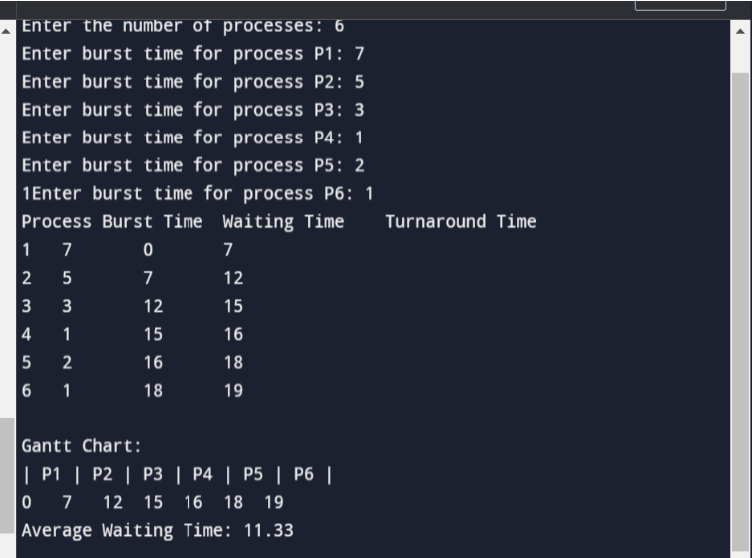Q1

**Q2**

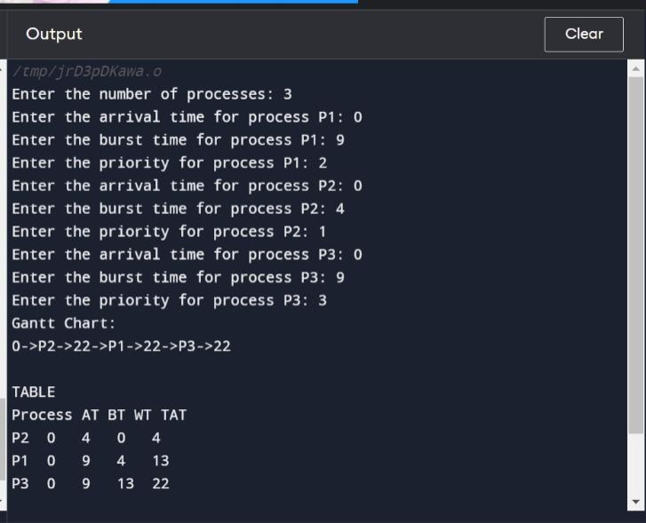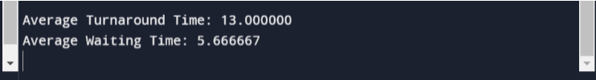

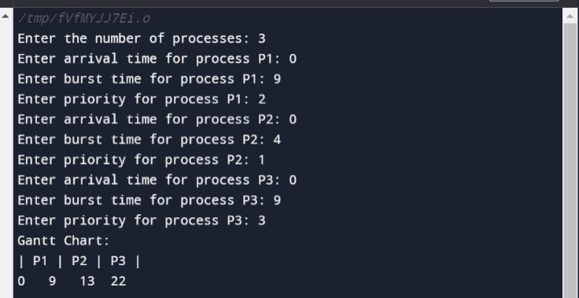**Q3**

